Framed Wall Hung ASHP Outdoor Unit Vibration Suppression
Mike Duclos – 3/7/2018

There is a companion spreadsheet containing the calculations used to determine the expected frequency suppression for different machines using different mounts, if you are interested, please contact Mike – mike@eeassociates.com

A client in Windsor, MA was very unhappy with a low frequency noise which occurred in places near and far from the outdoor unit, his description led me to think the outdoor unit was operating at the resonant frequency of the building.

The wall system is 2x8, 24 OC, cavities have 2” of ccSPF, then 5.25” of HD packed fiberglass, with 2” of polyiso on the exterior.

There are three wall hung compressors, the most problematic was the MUZ-FH18NA2, the other two are MUZ-FH06NA, the latter of which have not yet been addressed.

I asked the client to use an online audio generator adjusted to match the frequency that was causing the issue, and the client noted that the most objectionable sound occurred when the unit was just starting up, he reported 40 Hz was the issue.
http://www.szynalski.com/tone-generator/

Mitsubishi did not have a solution other than moving the units to the ground, but were very helpful in offering suggestions for an approach and answering a number of follow up questions as we investigated suppression of vibration transmitted to the building. They do have a paper on isolating large rooftop units, but it was not very helpful in this situation.

We finally arrived at an approach using neoprene mounts designed to reduce equipment vibration, some relevant details:

Karman Rubber Vibro-Insulators has a nice description of how to select the correct vibro-insulator, which I put into a spreadsheet.
http://karman.com/products/selection-steps

The inputs to the calculation required we know the weight of the machines, the FH18NA2 is 124 lbs, the FH06NA is 81 lbs,

The inputs to the calculation require we know the force on each mount, Mitsubishi directed me to C.O.G. data I missed, see page 59 of:
https://meus.mylinkdrive.com/files/M-Series_Engineering_Manual.pdf
but as we later discovered this is only part of the story.
The client found lower cost mounts available from Maon industries https://s3.amazonaws.com/s3.supplyhouse.com/product_files/ND%20Product%20Overview%202.pdf
So eventually parts were ordered and arrived and the client did the installation while I was there so I could witness ‘before’ and ‘after.’ The ‘before’ was pretty objectionable, I can easily understand why someone might be awakened by the machine starting in the middle of the night.

The selected isolator:

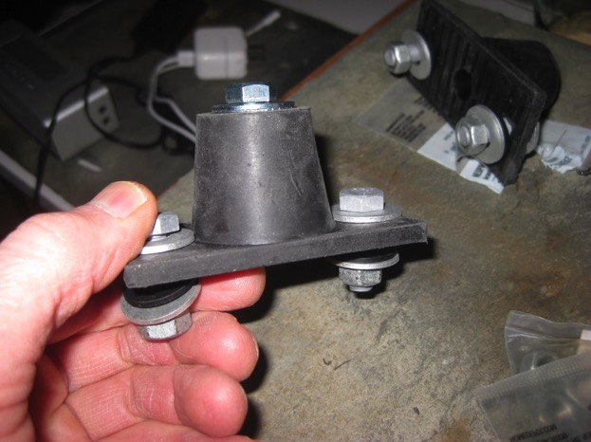

Overview of installation, the largest, most distant FH18NA2 is the unit to be isolated first:
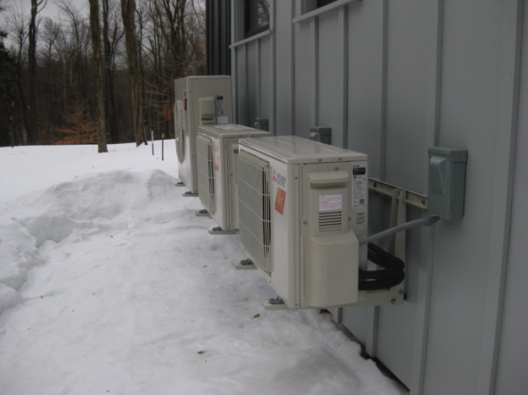

Lower part of cradle against siding, using some unknown vibration isolator used by the HVAC installer

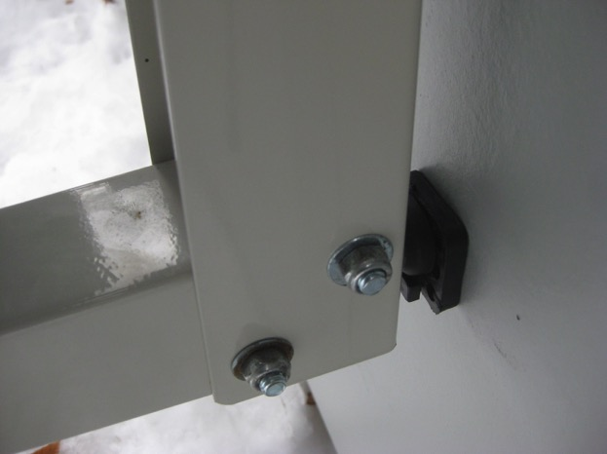

Installed rear, right - facing machine and house:

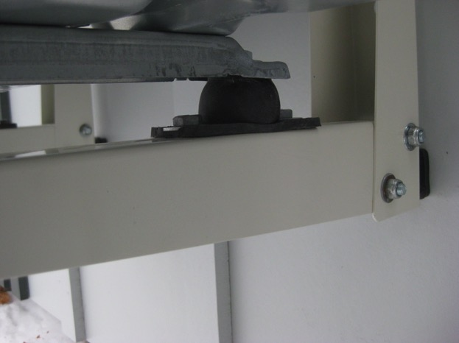

Installed front, right - facing machine and house:

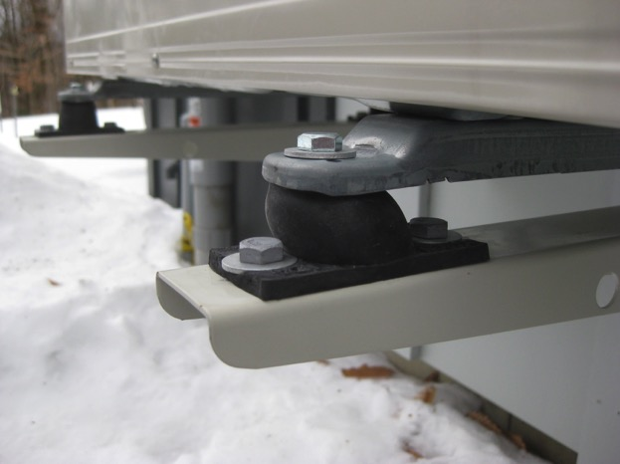

Installed rear, left - facing machine and house:

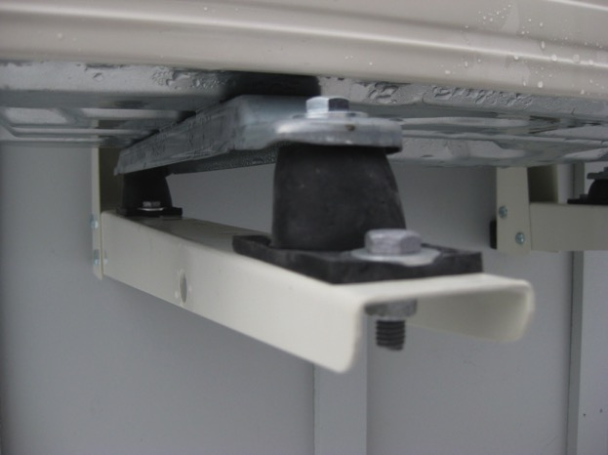

Note that there appears to be much more compression of the isolators on the right side, and particularly on the right front isolator. The Center of Gravity documentation indicates a definite bias on the right side mounting locations, but not so much on the front mounts.

In examining the installation and how the unit was placed on the cradle, we didn’t find anything noteworthy, other than the line set exits the machine on the right, and we think that the line set is causing the additional loading of the front right isolator.

The ‘after’ test was very satisfactory, still somewhat audible, but greatly reduced intensity, the client was very happy with the result.

Given that, the next larger isolator was ordered and eventually installed in the right front position.

This ‘stiffer’ isolator may cause more vibration transmission, if you go through the math for choosing a vibration isolator, ‘softer is better’ in that it addresses lower frequencies.

